Be optimistic, never laugh, always ask where I can improve. Read more

Puzzles

3D into 2D problems

Water and jar

Hats problems

Always try to make a story

Try to deal in bits

Consider worst case and try always to reduce

Try making odd group with mini size

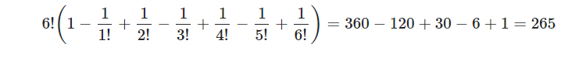 

Odd x to y = y/x+y

**DBMS**

See all formats and symbols

Subquery- If no row is returned ie null, so we must return consider it a valid comparison.

Always makes tuple

**OS**

Scheduling-If nothing is given, we run it only once